https://www.youtube.com/watch?v=ix9cRaBkVe0 : Bro Code
Installation : python interpreter (python.org) , second is IDE (PYcharm , VS Code)
New project
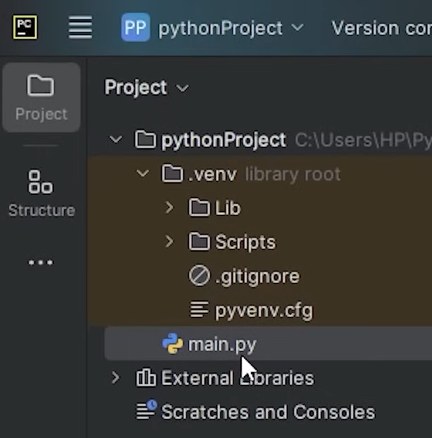

Comment by adding # at the start

# this is my first python program

Variable – container for a value (string , integer , float , Boolean )

first_name = “bro”
print(first_name)
print(f”hello {first_name}”)

if is_student:
print(“you are a student”)
else:
print(“you are not a student”)

Typecasting

str(),int(),float(),bool()

print(type(age))

Input()

name = input(“what is your name”)
age = int(input(“what is your age”))

Augumented assignments
friends += 1
friends -= 2
friends *= 5 (friends * 5)
friends **=2 (square of friends)
Math

import math
print(math.pi)
result = math.sqrt()

If
If age>=18:
print(“you are now sign up”)
else:
print(“you can’t be singed in ”)

logical operators
or , and , not

If temp>=0 and not is_sunny

Conditional expression

print(“positive” if num > 0 else “Negative”)

String functions

result = name.find(“ch”)
print(credit_number[0:4])
credit_bumber[0]

Rounding

Price1:.2f
Price2:.2f

While
While principle >0:
Do something
If principle <=0 :
Print(“we can’t take number less than of equal to 0”)

While true:
If:
//something
else:
//break

For loop
for x in range(1,11):
print(x)

Collection
List = [] , Set = {} , Tuple = ()
fruit = [“apple”,”mango”]
fruit[0]
fruit.append()
fruit.remove()
fruit.insert()

Set – does not include duplicates , it is unordered
fruit.add()
fruit.remove()

Tuple – () ordered and unchangeable , duplicates are ok

Dictionary
capitals = {“India”:”Delhi”,”USA”:”Washington”,”Russia”:”Moscow”}
capitals.get(“USA”)

Random
Import Random
random.randint(low,high)
random.random()
random.choice(options)
random.shuffle(cards)

Functions
def happy_birthday(name):
print(f“Happy birthday to you {name}”)

happy_birthday()

Iterables

numbers = [1,2,3,4,5]
for number in numbers:
print(number)

Membership operators
in , not in

if letter in word :

List comprehension
doubles = [x*2 for x in range(1,11)]

Match
match day
case 1 :
return “sunday”
case 2 :
return “Monday”
case _ :
return “wrong data”

module
import math
math is module

custome module (example.py) – python file with some methods , then we can import them
import example

Variable scope
(LEGB) : Local , enclosed , global , built-in
Variable within the function is local

If_name_ == _main_ : this script can be imported or run standalone , functions and classes in this module can be reused without the main block of code executing

def main()
# your program goes here
If_name_ == _main_ (double underscore)
main()

to check which file is set as main function in python

dunder name is equal to dunder main

Object
A bundle of related attributes (variables) and methods (functions)
Class : used to design the structure and layout of an object

class Car:
def __init__(self, model,year , color , for_sale)
self.model = model
self.year = year
self.color = color
self.for_sale = for_sale

car1 = new Car(“Mustang”, 2024, “red”,False)

Class Variables
Shared among all instances of class , defined outside the constructor , allow you to share data among all objects created from that class

class student:
class_year = 2024

studen1.class_year and student2.class_year return the same value also Student.class_year
they are defined outside the constructor

Inheritance
Allows a class to inherit attributes and methods from another class

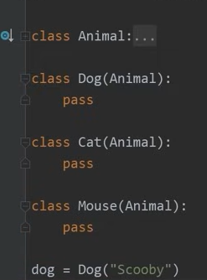

class Dog(Animal)
pass
class Cat(Animal)
pass

multiple inheritance C(A,B)
multi level inheritance A -> B(A) -> C(B)

Super()
Function used in a child class to call methods from a parent class (super class) , Allows you to extend the functionality of the inherited methods .

class Circle(shape):
def __init__(self , color , is_filled , radius)
super().__init__(color,is_filled)

Polymorphism
Two ways to achieve it – Inheritance , Duck typing

Duck typing
Object must have the minimum necessary attributes / methods
animals = [Dog(),Cat(),Car()]

for animal in animals
animal.speak()

speak method is there in car also , even though it is not inherited by the animal

Static methods & instance methods

@staticmethod
def is_valid_position(position):

Class methods

@classmethods
def get_count(cls):
return f”Total # of students : {cls.count}”

cls refers to the class not the instance and count is the class variable

Magic methods
Dunder methods – they are automatically called by many of python’s built-in operations

Ex __init__(self, text)

def __str__(self)
return (f”{self.title} by {self.author}”)

def __eq__(self,other)
return self.name == other.name

for overwriting the string ,default equal behaviour , same for less than , greater than and add
book1 + book2 , book1 > book2 , book1 == book2 print book1

@Property
Decorator used to define a method as property – it can be accessed as like an attribute , we can write additional logic when read , write or delete attributes

@property
def width(self):
pass

@width.setter
def width(self,new_width)

Decorator
A function that extends the behavior of another function , without modifying the base function .

def add_sprinkles(func)
def wrapper():
print(“you add sprinkles”)
func()
return wrapper

@add_sprinkles
def get_ice_cream():
print(“here is your ice cream”)

exception
An event that interrupts the flow of a program

try:
Code
except ZeroDivisionError:
print(“you can’t divide by zero”)
finally:
code to run

we can also catch generic Exception

File creation
Import os

os.path.exists(file_path)

Datetime

Import datetime

Multithreading

Used to perform multiple tasks concurrently – multi tasking
Good for I/O bound tasks like reading files or fetching data from APIs

chore1 = threading.Thread(target=walk_dog)
chore1.start()

chore2 = threading.Thread(target=take_out_trash)
chore2.start()

Install packages

pip install requests (pip is the python package manager)

Graphical User Interface

PyQt5 introduction
pip install PyQt5

import sys
from PyQt5.QtWidgets imports QApplication , QMainWindow

class Mainwindow(QMainWindow):
def __init__(self):
super().__init__()
def main():
app = QApplication(sys.argv)
window = MainWindow()
window.show()
sys.exit(app.exec_())

if __name__ == “__main__”
main()

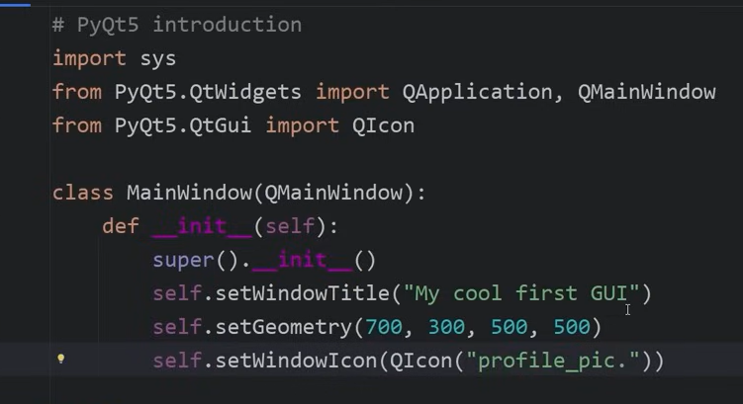

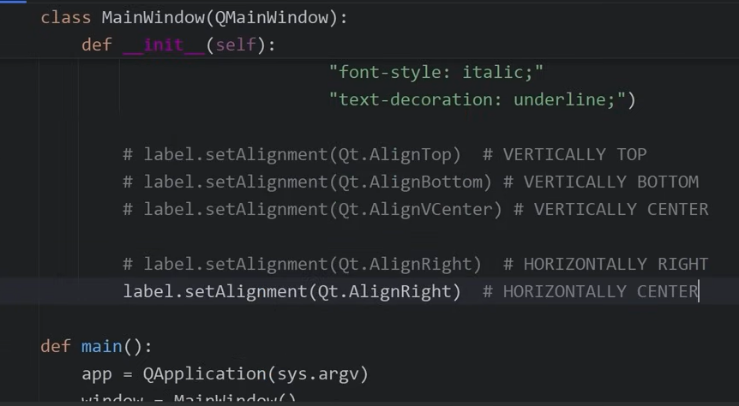

#PyQt5 layouts

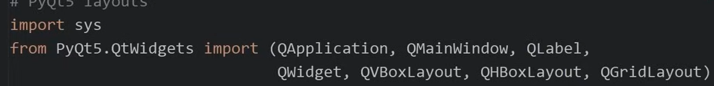

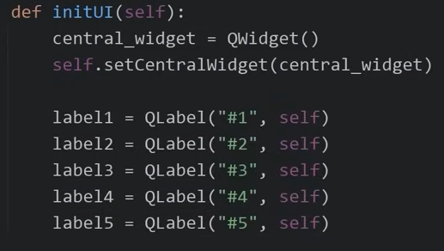

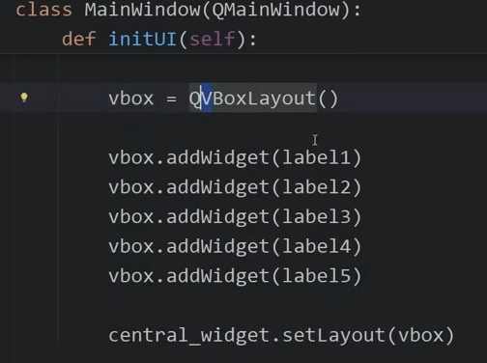
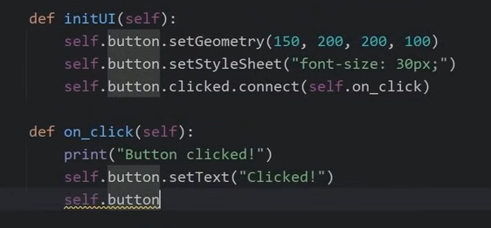

Applying CSS properties

